

Dear Patient,

Welcome to ClearView Eye Consultants! Thank you for placing your trust in our team.

The focus of our practice is surgery and I am dedicated to being the best surgeon I can be. I am continually refining my techniques to provide the latest technology and most effective care to my patients.

My total commitment to providing you with the best surgical care requires a team approach. Our administrative, technical, optometric and ophthalmic clinical teams are specifically trained to support me before, during and after your surgery. As a result, some or all of your care following surgery will be provided by the members of our clinical team and your referring doctor. In addition, I am always available if there are any specific questions or concerns.

I hope you will take a few minutes to review the enclosed information prior to your visit. We will review this information together on the day of your appointment. We want you to be fully informed before any decisions are made regarding your cataract surgery.
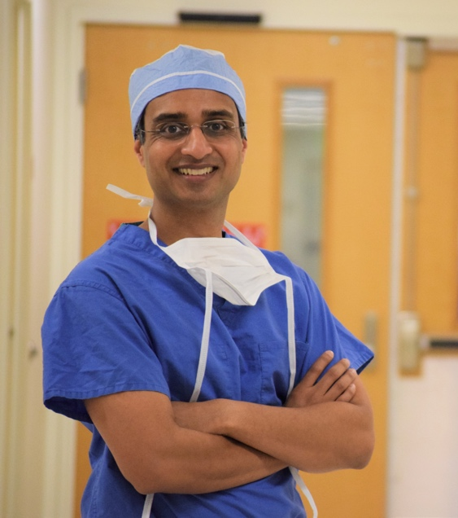
I look forward to seeing you soon.
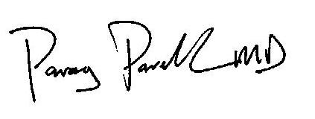
Parag Parekh, MD

WHAT IS A CATARACT?
A cataract is a clouding of the natural lens in your eye, which results in blurred or distorted vision. Cataracts are most often found in older patients but they can occur at any age. A cataract can progress until eventually there is significant loss of vision in your eye. Neither diet, medications, new glasses nor eye exercises will make the cataract go away. Surgery is required to improve vision.

WHAT IS CATARACT SURGERY?
Cataract surgery is an outpatient procedure where the cloudy lens is removed and it is replaced with a new lens, called an implant.

QUESTIONS ABOUT YOUR ACTIVITIES & VISION PREFERENCES:
Your answers to these questions will help you focus on which aspects of your vision are most important to you. This helps guide your surgeon in recommending the best lens to fit your needs:

- How important is it for you to be able to see clearly without glasses after surgery?
_______Very important – “I prefer not to wear glasses after surgery”
_______Moderately – “I'm not sure”
_______Not at all – “I don't mind wearing glasses after surgery”

- If you work, what are some of your daily tasks at work? ____________________________
- Do you need to do a lot of night driving? Yes No
- Do you use a computer on a daily basis? Yes No
- What are your favorite hobbies? __________________________________________
- Have you ever tried monovision contact lenses? Yes No
- How would you describe your personality?
Very easy going <-----------------> In Between <--------------> Very detail oriented/perfectionist

- Which zone of vision is the MOST IMPORTANT group to you? Pick only one.

NEAR Vision DISTANCE Vision

ZONE 1 ZONE 2 ZONE 3
(12-20 in) (2-4 ft.) (20-100 ft.)
Newsprint Cooking TV
Phone book Computer Driving
Maps Price Tags Golf
Sewing Cleaning Road signs


WHAT ARE THE OPTIONS OFFERED?
Due to advancements in technology, cataract surgery is considered to be one of the safest and most successful surgeries in the United States today. Dr. Parekh offers the full range of options to you--from the most basic surgery (similar to what other local eye doctors offer) to the most advanced options to customize your vision. Our goal is to customize your experience to your individual lifestyle needs.
During your visit, we will take very precise measurements of your eye. This is why we ask contact lens wearers to not wear their contact lenses for at least several days prior the evaluation--this helps with the accuracy of the measurements. Based on these measurements, Dr. Parekh will explain which options might fit your needs.

1. Distance Vision -- This is the option for patients who wish to have good distance vision (Zone 3), without the use of glasses, but who don't mind wearing "reading glasses" or "cheaters" for near (Zone 1) or intermediate (Zone 2) vision. This option includes several advanced diagnostic tests and procedures that are not routinely covered by insurance, but help the doctor to give you the best possible outcome.

2. Distance Vision for Patients with Previous LASIK/PRK -- This is the option for patients who have had LASIK or PRK previously, and who wish to have good distance vision (Zone 3), without the use of glasses, but who don't mind wearing "reading glasses" or "cheaters" for near (Zone 1) or intermediate (Zone 2) vision. This option includes several advanced diagnostic tests and procedures that are not routinely covered by insurance, but help the doctor to give you the best possible outcome.

3. Near Vision -- This is the option for patients who wish to have good near vision (Zone 1), without the use of glasses, but who don't mind wearing glasses for distance (Zone 3) vision. This option is also available to patients who have had previous LASIK/PRK. This option includes several advanced diagnostic tests and procedures that are not routinely covered by insurance, but help the doctor to give you the best possible outcome.

4. Distance & Near Vision using Monovision -- This is the option for patients who desire both distance and near vision (Zones 1-3). It involves having distance vision in the dominant eye, and reading vision in the other eye. This option can be done for patients with low, moderate or high astigmatism, and those who have had LASIK/PRK previously. It is important to try monovision first; we can assist you with this. In addition, this option includes several advanced diagnostic tests and procedures that are not routinely covered by insurance, but help the doctor to give you the best possible outcome.

5. Distance & Near Vision using a Multifocal Lens Implant -- This is the option for patients who desire both distance and near vision (Zones 1-3), but who do not tolerate monovision. In addition, it includes several advanced diagnostic tests and procedures that are not routinely covered by insurance, but help the doctor to give you the best possible outcome.

6. Basic Option -- This is the option for patients who don't mind wearing bifocal or progressive (no-line bifocal) glasses after surgery.

Visual Function Questionnaire

Dr. Parekh wants to get a good sense of the visual difficulties you are having. Please take a moment to fill out this questionnaire and bring it with you to the appointment.

1. Do you have any difficulty, even with glasses, reading small print such as newspapers, labels on medicine bottles, a telephone book or food labels?
Yes No Not applicable

If YES, how much difficulty do you currently have?
A little A moderate amount A great deal I'm unable to do the activity

2. Do you have any difficulty, even with glasses, reading larger print, like numbers on a telephone?
Yes No Not applicable

If YES, how much difficulty do you currently have?
A little A moderate amount A great deal I'm unable to do the activity

3. Do you have any difficulty, even with glasses, seeing steps, stairs or curbs in dim light?
Yes No Not applicable

If YES, how much difficulty do you currently have?
A little A moderate amount A great deal I'm unable to do the activity

4. Do you have any difficulty, even with glasses, reading traffic signs, street signs or store signs?
Yes No Not applicable

If YES, how much difficulty do you currently have?
A little A moderate amount A great deal I'm unable to do the activity

5. Do you have any difficulty, even with glasses, doing fine handwork like sewing, knitting, using hand tools or carpentry?
Yes No Not applicable

If YES, how much difficulty do you currently have?
A little A moderate amount A great deal I'm unable to do the activity

6. Do you have any difficulty, even with glasses, writing checks or filling out forms?
Yes No Not applicable

If YES, how much difficulty do you currently have?
A little A moderate amount A great deal I'm unable to do the activity

7. Do you have any difficulty, even with glasses, playing games such as bingo, dominos, or card games?
Yes No Not applicable

If YES, how much difficulty do you currently have?
A little A moderate amount A great deal I'm unable to do the activity

8. Do you have any difficulty, even with glasses, watching television?
Yes No Not applicable

If YES, how much difficulty do you currently have?
A little A moderate amount A great deal I'm unable to do the activity

9. Do you have any difficulty, even with glasses, cooking?
Yes No Not applicable

If YES, how much difficulty do you currently have?
A little A moderate amount A great deal I'm unable to do the activity

10. Do you have any difficulty, even with glasses, driving the day?
Yes No Not applicable

If YES, how much difficulty do you currently have?
A little A moderate amount A great deal I'm unable to do the activity

11. Do you have any difficulty, even with glasses, driving at night?
Yes No Not applicable

If YES, how much difficulty do you currently have?
A little A moderate amount A great deal I'm unable to do the activity

Name: ___________________________________________________________

PAST MEDICAL HISTORY: (please circle all that apply)

Arthritis
Asthma
Atrial fibrillation
BPH—Prostate Enlargemt
CVA—Stroke
COPD/Emphysema

Depression
Diabetes
Kidney Disease
Epilepsy/Seizures
High Blood Pressure
HIV/AIDS

High Cholesterol
Lymphoma
Leukemia
Colon Cancer

NONE

OTHER: _________________________________________________________________________________________

PAST SURGICAL HISTORY: (please circle all that apply)
Heart Artery Bypass
Colon Surgery/Removal

NONE

OTHER: _________________________________________________________________________________________

PAST EYE HISTORY: (please circle all that apply) L = Left Eye R = Right Eye
Contact Lenses | L R | Fuchs Dystrophy | L R | Retina Tear | L R
Narrow Angles | L R | Glaucoma | L R | "Crossed” Eyes | L R
Cataract | L R | “Lazy” Eye | L R | Floaters | L R
Corneal dystrophy | L R | Retina Detachment | L R | Glasses
Macular Degeneration | L R | Eye Injury | L R
Dry Eyes | L R | Diabetic retinopathy | L R
Macular Pucker/ERM | L R | Ocular Migraine | L R | OTHER:
 |  |  |  | ______________________ | L R

PAST EYE SURGERY: (please circle all that apply)
Year Year Year
Cornea transplant | L R |  | Glaucoma Trab | L R |  | YAG Cap | L R
DSEK Cornea  Transplant | L R |  | Retina Detachment  Repair | L R |  | Eye  straightening | L R
Goniotomy | L R |  | Vitrectomy Surgery | L R
Cataract surgery | L R |  | Retina Injection | L R
Glaucoma Tube | L R |  | LASIK/PRK | L R |  | OTHER | L R
Glaucoma Laser SLT | L R |  | Glaucoma Laser PI | L R |  | __________________ | L R
Retina Laser L R |  |  | Pterygium | L R |  | __________________ | L R
Eyelid Surgery | L R |  |  |  |  | __________________ | L R
Macular Hole Surg. | L R

PHARMACY INFO: PRIMARY CARE DOCTOR:
Name: _______________________________________ Name: _______________________________________
Tel Number: ________________________________ Tel Number: ________________________________
Address: _____________________________________ Address: _____________________________________

MEDICATIONS: (Please list all current medications)
________________________ ________________________ ________________________ ________________________
________________________ ________________________ ________________________ ________________________
________________________ ________________________ ________________________ ________________________
________________________ ________________________ ________________________ ________________________
________________________ ________________________ ________________________ ________________________

MEDICATION ALLERGIES: (Please list all allergies)
________________________ ________________________ ________________________ ________________________
________________________ ________________________ ________________________ ________________________

SOCIAL HISTORY: (Please circle all that apply)

CIGARETTE SMOKING:  Never smoked  Smokes daily  Former smoker  Packs per day:  Total yrs of smoking: ____ | ALCOHOL:  Do not drink at all  Less than 1 drink/day  1-2 drinks/day  More than 3 drinks/day | DRIVING STATUS:  Daytime Driving Y N  Night Driving Y N  OCCUPATION:  ____________________________

Have you had the pneumonia vaccine? Yes No
Have you had the COVID vaccine? Yes No
Do you have a healthcare proxy? Yes No
Do you have a living will? Yes No

FAMILY HISTORY: (please circle all that apply) M=Mother F=Father B=Brother S=Sister

Glaucoma M F B S

Retinal Detachment M F B S

Cataract Surgery M F B S
Complications

ALERTS: Do you have any of the following? (Circle if YES)
Allergy to adhesive
Allergy to lidocaine
Allergy to Fluorescein
Allergy to Dilation Drops
Artificial Heart Valve
Pacemaker
Defibrillator
Rapid heart beat with epinephrine
Blood Thinners
Artificial joints within past two years
Premedication prior to procedures
MRSA
Pregnancy or planning a pregnancy
Steroid responder--Eye Pressure

